Joel Lantigua

Linux Administrator

Setup server

9/10/22

**Ubuntu Server Setup**

Today we are going to be setting up an Ubuntu server. First thing we should do is look for the ubuntu ISO file that we need to install our server by going to <https://ubuntu.com/download/server>. Once you’ve hit the link go ahead and clink on the green box where is says **Download Ubuntu server 22.04.1 LTS.** Once you’ve started the download of the ubuntu server you can go ahead and open VMware. In VMware you want to click on **file** and then select **New Virtual Machine**. After that is selected, you are going to want to select **Typical** which is the recommended configuration for a new virtual machine. Once you have clicked on next the new virtual machine wizard is going to ask how the operating system will be installed. You are going to select **Installer disc image file (iso):** After you have selected that click on **Browse** and find the Iso file you’ve downloaded for ubuntu then click next and use the default settings until you see **finished**.

Once you’ve clicked on finished then the virtual machine should start to boot up. Once it boots up using your keyboard, you are going to want to select **Try or Install Ubuntu Server** by pressing the enter keyas shown in the image below Text

Next, you will be asked for language and keyboard configurations which can be left as default and then you can select done. After you’ve selected done the next page will ask you to choose a type of install for the ubuntu server. You are going to select the first option which is **Ubuntu Server.** Once selected hit done to move on to the next page as shown in the picture below.

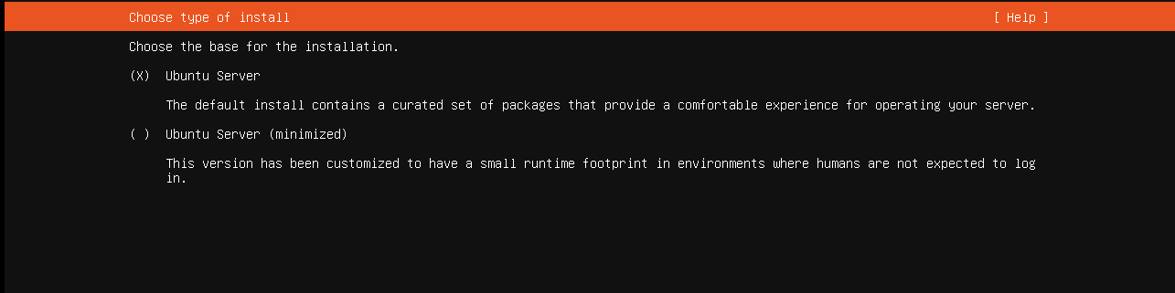

This next page is going to ask about **Network connections**. Once you’re on this page your server should already have an IP address assigned to it, as you can see in the picture below my server has an IP address assigned to it. now we can select done and move on to the next page.

After you’ve selected done and moved on to the next page it will bring up the proxy configuration page. you can leave this page blank and just select done to move on to the next. The very next page will be asking for a Mirror address which should automatically be already filled out so we can go ahead and select done to move on to the next page.

After you have selected done it will bring you to the guided storage configuration page, on this page you can choose to select different storage drives if you have any. In my case I just used the default selections which was **Use an entire disk & set up this disk as an LVM group.** Then select done.Text

The next page is going to be another storage configuration page. On this page you are going to leave everything how it is and select done. Once you have selected done it will also ask if you want to continue because you won’t be able to go back to any of the previous pages. Text

Once you have selected continue it will bring you to the profile setup page. Here you will give your server a name and also create a profile for your server login. Once you have completed this page goahead and select done to move on. Graphical user interface, text

This last page is for the ssh setup. SSH is a secure shell allowing you to access your server remotely through another application like putty also allowing the server to share files with other servers. So for this page you are going to want to select **install openssh server** then select done to move on.Text

Next the server will finish installing everything. Once it’s done installing everything then you are ready to reboot the server and launch it.

After you have rebooted the server and it launches back up, the first thing it will ask for is the login. Use the username that you crated when you were doing the profile setup page. In my case my username is Joel after you insert your username hit enter and then the server will ask for your password you created for the user you inserted. Note when typing in the password the screen will look blank like if you weren’t typing in anything. Just keep in mind that it is typing in the password. After you inserted the password hit enter and you will be logged into your server you just created.Text
